Small Rhombicuboctahedron

Definition
# Source: AI Source: Provided by: [Data Path: Persons Table -> ID Column: 1, Name_En Column: Motasem Essam] -> From: [ChatGPT] on [7/25/2026]
A Rhombicuboctahedron, also called a Small Rhombicuboctahedron, is a convex Archimedean solid composed of 26 regular polygonal faces: 8 equilateral triangles and 18 squares.
It has 24 vertices and 48 edges. Every vertex has the same arrangement of faces: one equilateral triangle and three squares.

Geometric Structure
# Source: AI Source: Provided by: [Data Path: Persons Table -> ID Column: 1, Name_En Column: Motasem Essam] -> From: [ChatGPT] on [7/25/2026]
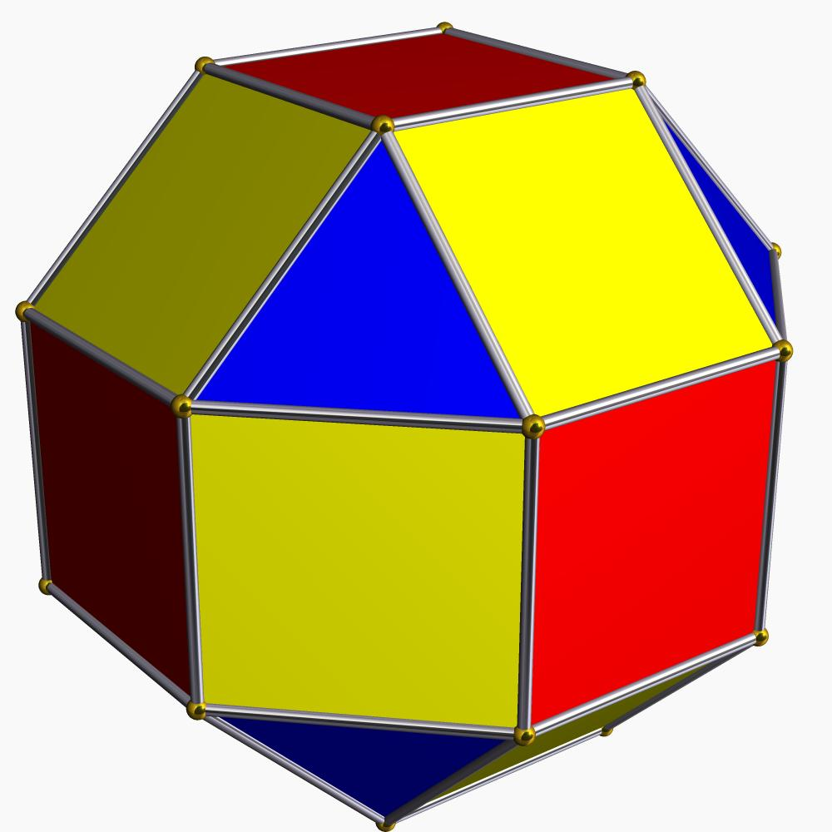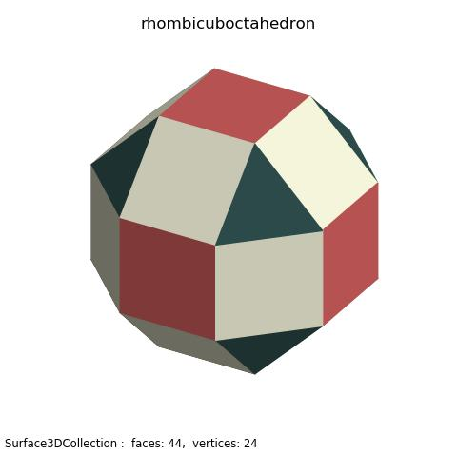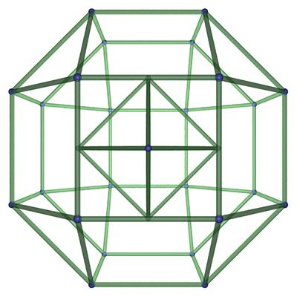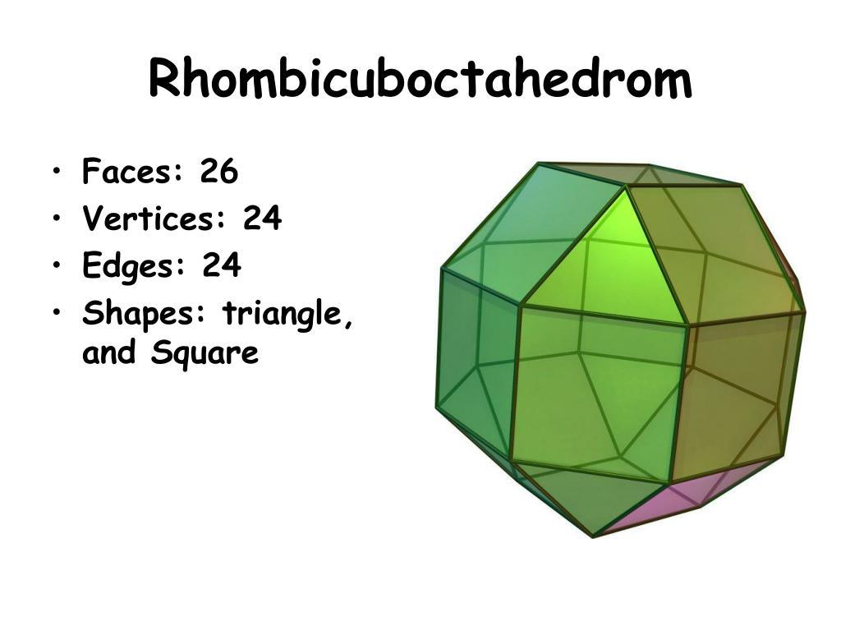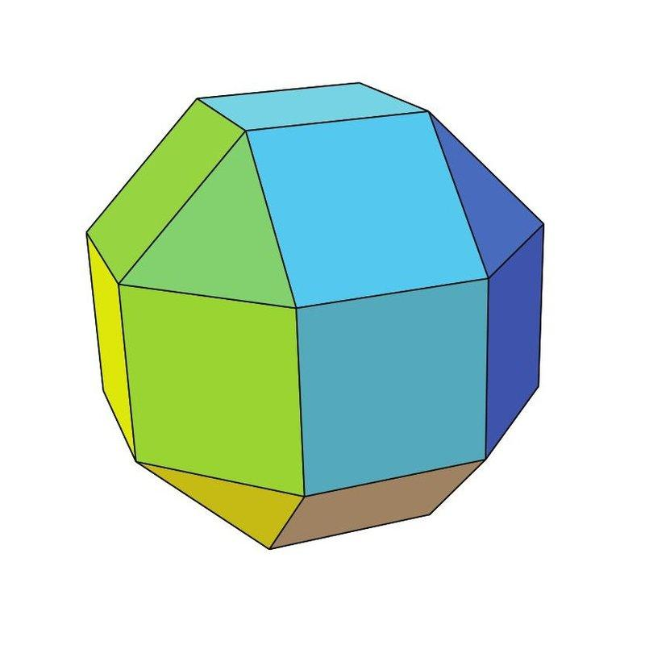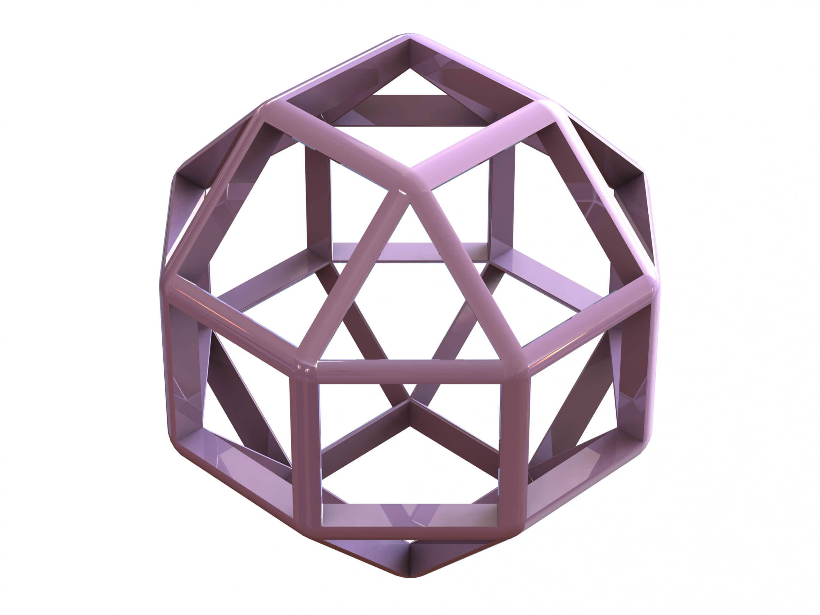
The solid consists of:
- 8 Triangular Faces: Equilateral triangles.
- 18 Square Faces: Regular squares.
- 24 Vertices: Each vertex is shared by one triangle and three squares.
- 48 Edges: All edges have equal length.

Face Composition
# Source: AI Source: Provided by: [Data Path: Persons Table -> ID Column: 1, Name_En Column: Motasem Essam] -> From: [ChatGPT] on [7/25/2026]
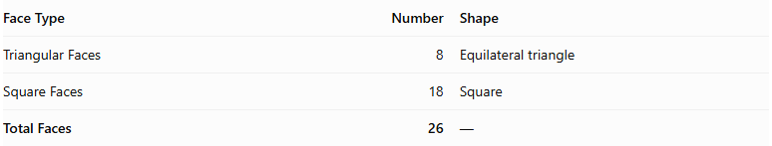
Face Type | Number | Shape
Triangular Faces | 8 | Equilateral triangle
Square Faces | 18 | Square
Total Faces | 26 | —

Mathematical Properties
# Source: AI Source: Provided by: [Data Path: Persons Table -> ID Column: 1, Name_En Column: Motasem Essam] -> From: [ChatGPT] on [7/25/2026]
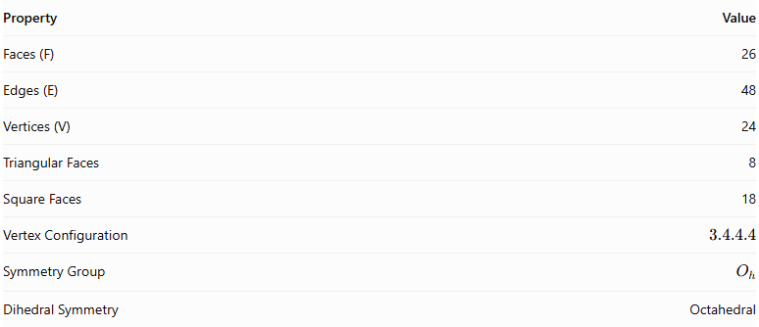
Property | Value
Faces (F) | 26
Edges (E) | 48
Vertices (V) | 24
Triangular Faces | 8
Square Faces | 18
Vertex Configuration | $$3.4.4.4$$
Symmetry Group | $$O_{h}$$
Dihedral Symmetry | Octahedral
Euler's Formula:
$$V-E+F=2$$
$$24-48+26=2$$
Surface Area:
For edge length $a$:
$$A=(18+2\sqrt{3})a^{2}$$
Volume:
$$V=\frac{12+10\sqrt{2}}{3}a^{3}$$

Geometric Characteristics
# Source: AI Source: Provided by: [Data Path: Persons Table -> ID Column: 1, Name_En Column: Motasem Essam] -> From: [ChatGPT] on [7/25/2026]
- It is a convex Archimedean solid.
- All faces are regular polygons.
- All edges have equal length.
- All vertices have identical arrangements of faces.
- It has octahedral symmetry.
- Its faces consist of two polygon types: equilateral triangles and squares.
- Its dual polyhedron is the Deltoidal Icositetrahedron.

Geometric Construction
# Source: AI Source: Provided by: [Data Path: Persons Table -> ID Column: 1, Name_En Column: Motasem Essam] -> From: [ChatGPT] on [7/25/2026]
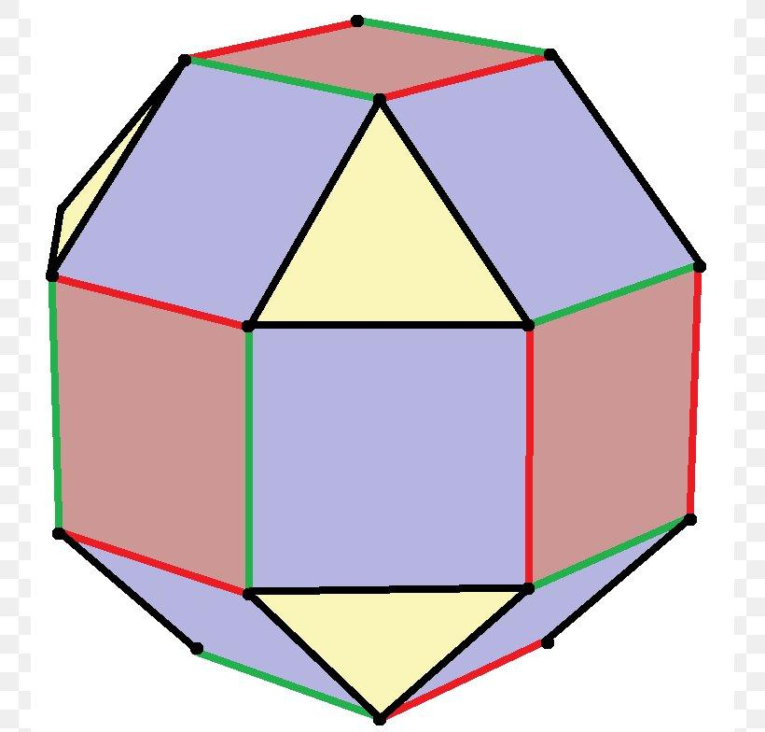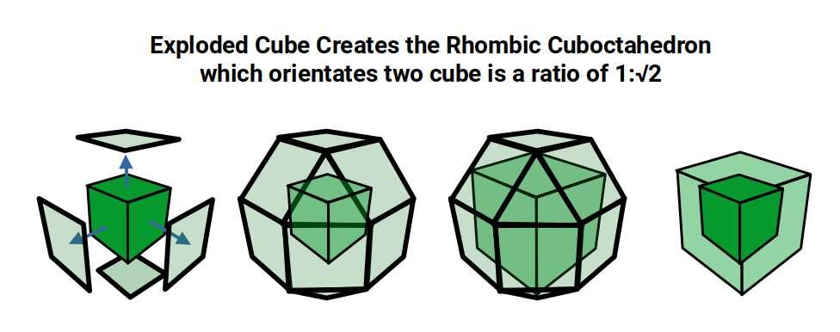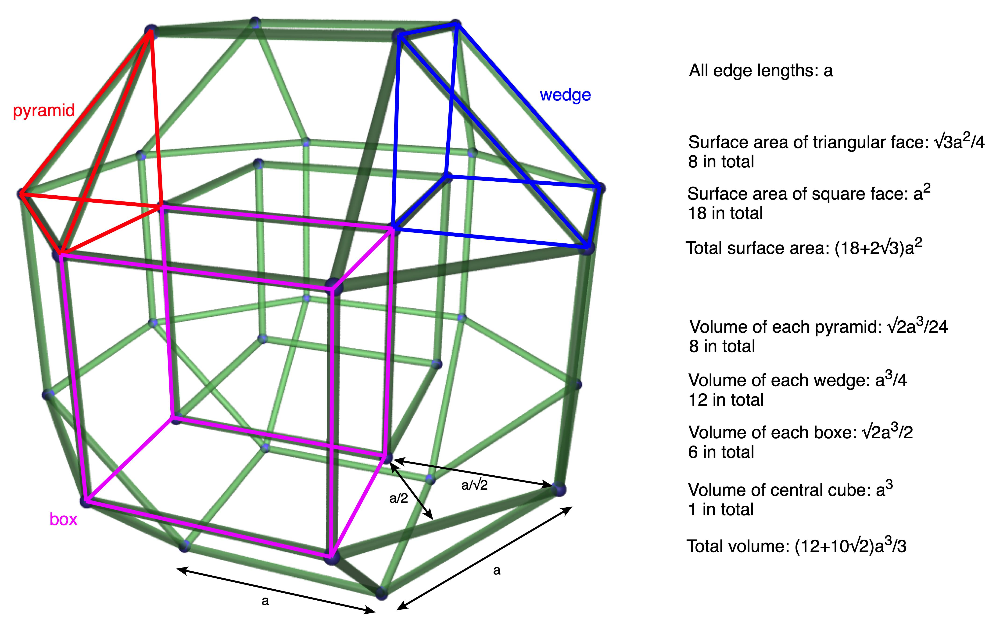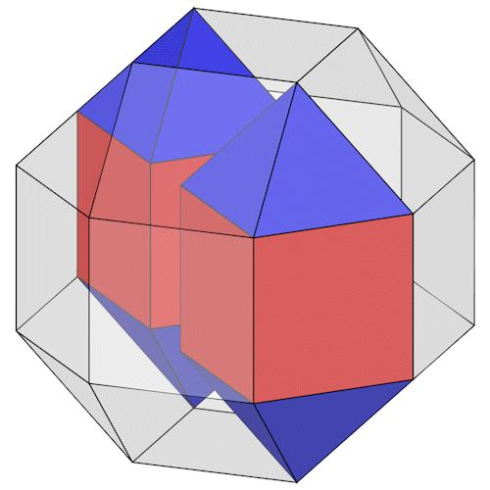
A Rhombicuboctahedron can be decomposed into three principal components:
- Upper Square Cupola: A square cupola forming the upper portion.
- Central Octagonal Prism: An octagonal prism connecting the two cupolas.
- Lower Square Cupola: A second square cupola forming the lower portion.
The components are joined in a suitable orientation to form the complete solid.

Related Geometric Solids
# Source: AI Source: Provided by: [Data Path: Persons Table -> ID Column: 1, Name_En Column: Motasem Essam] -> From: [ChatGPT] on [7/25/2026]
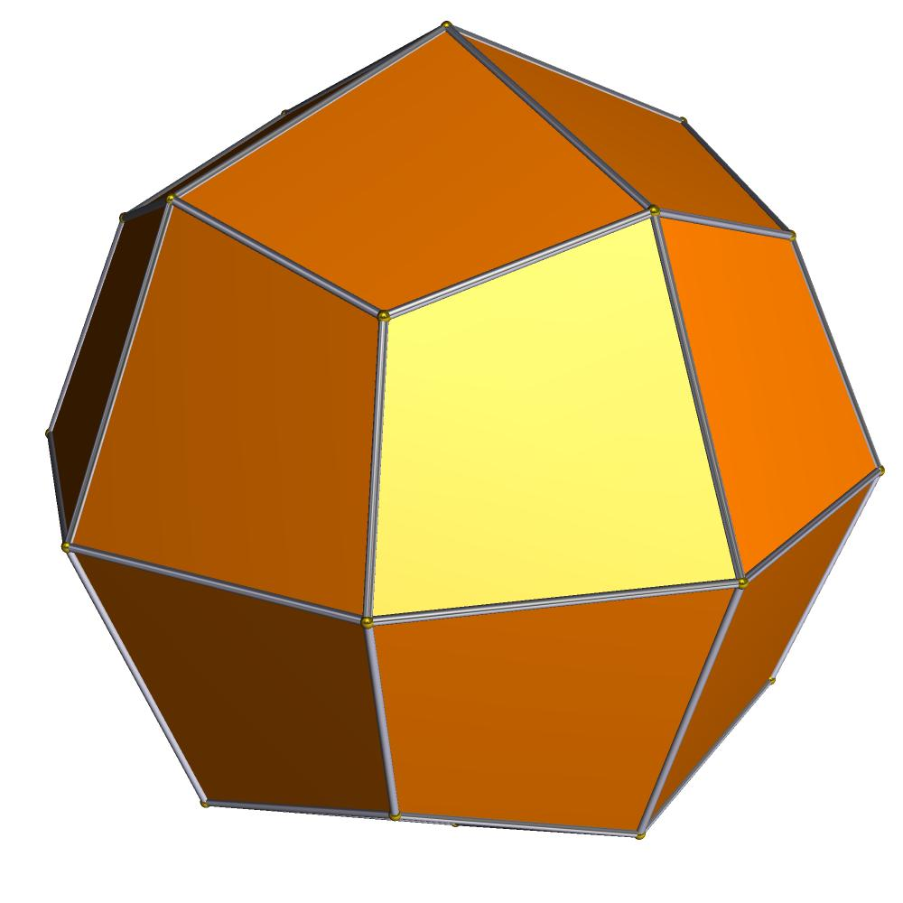
Deltoidal Icositetrahedron
The dual polyhedron of the Rhombicuboctahedron.
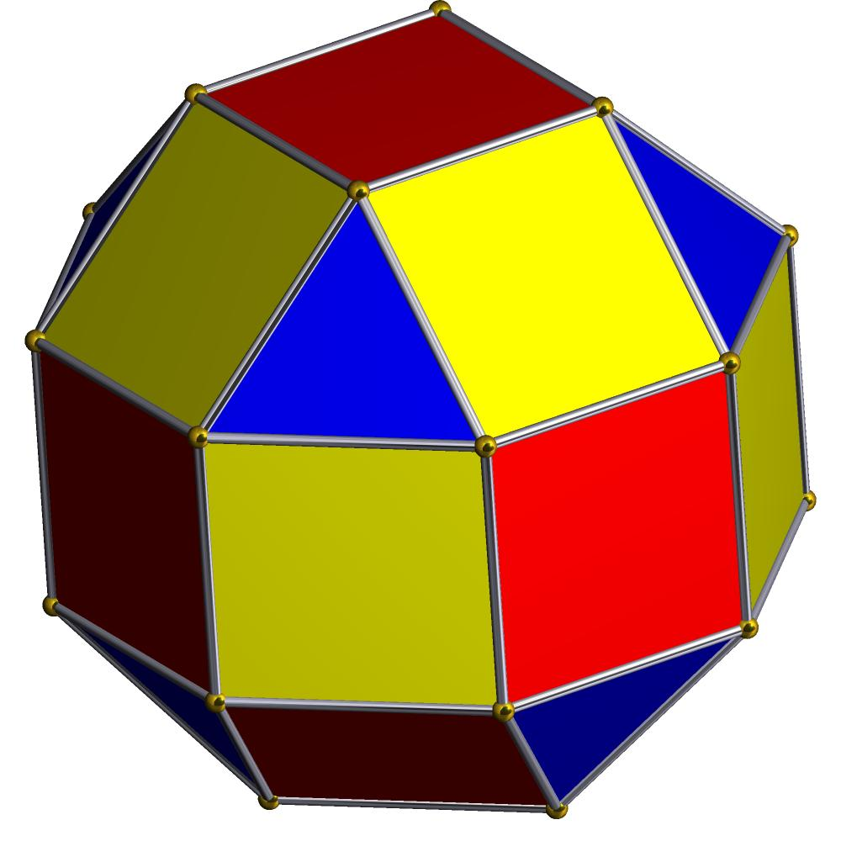
Elongated Square Gyrobicupola
Also called the Pseudorhombicuboctahedron. It has the same face counts and vertex configuration but is not an Archimedean solid.
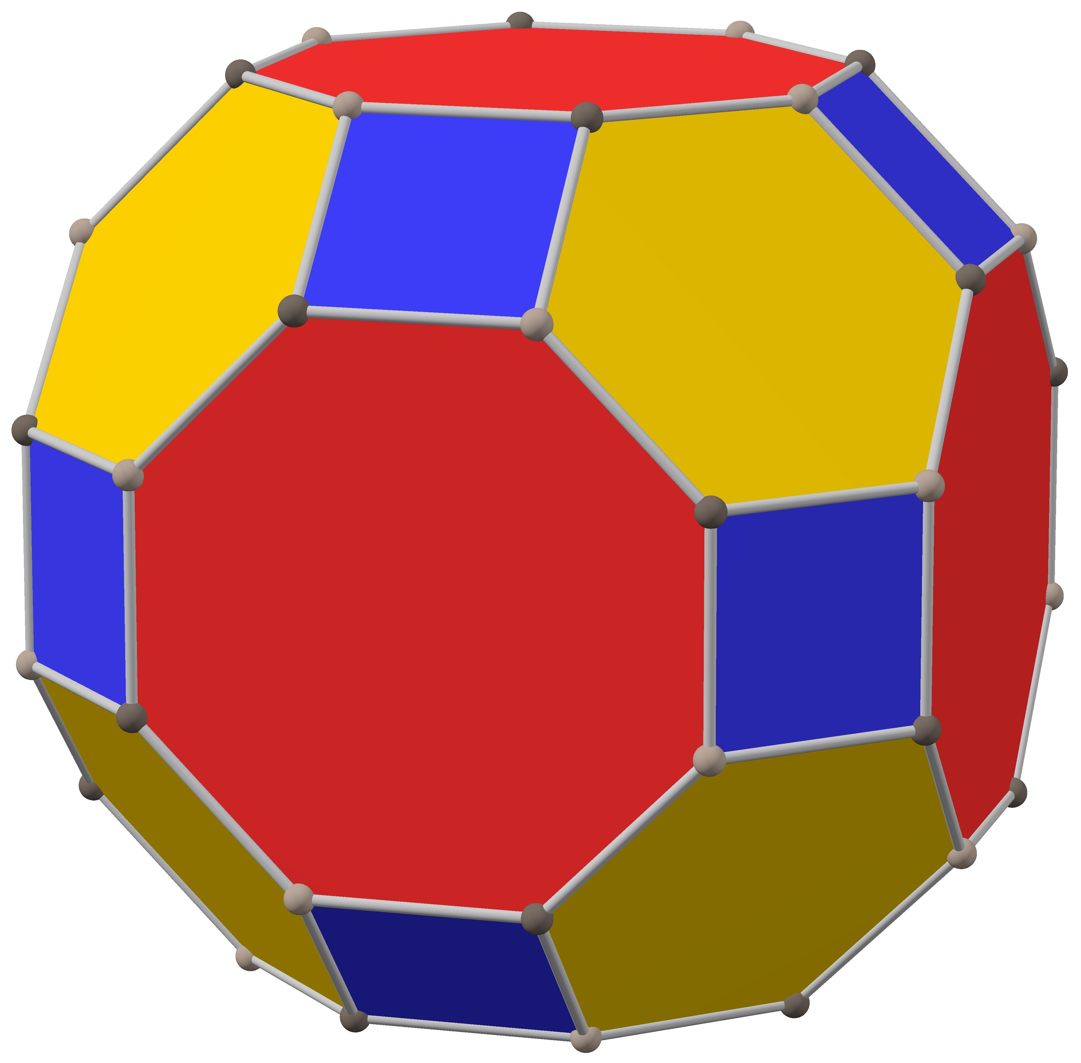
Great Rhombicuboctahedron
Also known as the Truncated Cuboctahedron. It is a different Archimedean solid.

Key Points
# Source: AI Source: Provided by: [Data Path: Persons Table -> ID Column: 1, Name_En Column: Motasem Essam] -> From: [ChatGPT] on [7/25/2026]
- The Rhombicuboctahedron is one of the 13 classical Archimedean solids.
- It contains 8 equilateral triangular faces and 18 square faces.
- Its vertex configuration is $3.4.4.4$.
- It has 26 faces, 48 edges, and 24 vertices.
- Its dual is the Deltoidal Icositetrahedron.
- It should not be confused with the Great Rhombicuboctahedron or the Pseudorhombicuboctahedron.

Main Classification
# Source: AI Source: Provided by: [Data Path: Persons Table -> ID Column: 1, Name_En Column: Motasem Essam] -> From: [ChatGPT] on [7/25/2026]
Solid Geometry
└── Types of Solids
└── Archimedean Solids
└── Rhombicuboctahedron
├── Triangular Faces
├── Square Faces
├── Vertices
├── Edges
└── Geometric Properties

Conclusion
# Source: AI Source: Provided by: [Data Path: Persons Table -> ID Column: 1, Name_En Column: Motasem Essam] -> From: [ChatGPT] on [7/25/2026]
The Rhombicuboctahedron is a convex Archimedean solid with 26 regular faces, combining equilateral triangles and squares in a uniform arrangement. Its symmetry, face composition, and relationship to other polyhedra make it an important solid in three-dimensional geometry.

